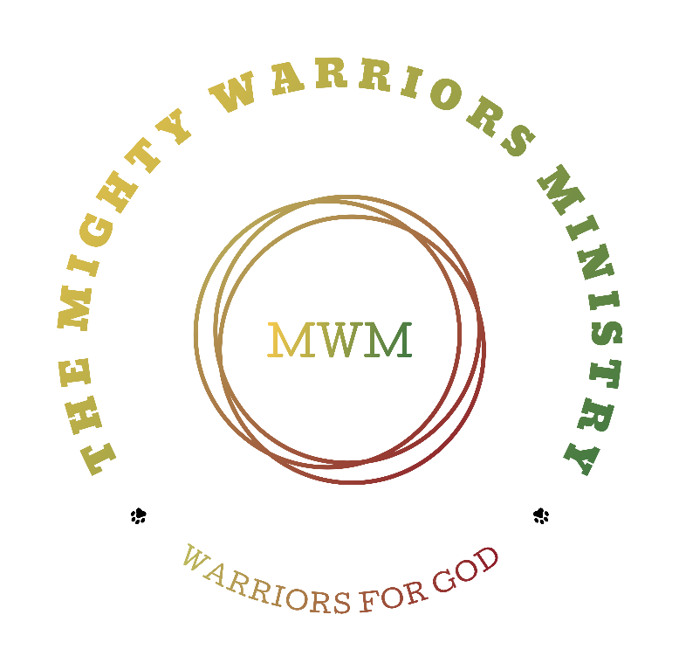

Mighty Warriors Ministry: Strategic Investment Insights for Investors, Benefactors, and Christian Community Leaders
Allen Gibson
Pastor/Founder
The Mighty Warriors Ministry
2222 Aloha Drive #403
Honolulu Hawaii 96815
Email: Themightywarriorsministry54@gmail.com
Website: themightywarriorsministry.com
Table of Contents
Founder 2
Uniting for a Cause: Join Us in Expanding The Mighty Warriors Ministry 3
Vision Statement 4
Mission Statement 4
Our Core Values: 4
Beliefs 5
The Mighty Warriors Ministry Foundation 5
The Mighty Warriors Ministry Objectives 5
Projects and Ministries 5
Role of The Mighty Warriors Ministry 6
Let us continue to shine brightly, illuminating the path for others and inspiring lasting change in the world. Together, we can make a difference that echoes through generations, all for the glory of God. 7
Strategic Programs 8
Our Ministries Programs objectives and impacts 8
Highlights of our initiatives include: 9
The Ministry Impact 9
Looking Forward 10
Operational Cost Breakdown for The Mighty Warriors Ministry 11
Annual Operating Costs 11
Specialized Programs and Support Services 11
Operation Setup 11
Global and Community Outreach 11
Total Costs 11

Founder
Allen Gibson, the visionary founder of The Mighty Warriors Ministry, is a distinguished Christian leader with a fervent commitment to faith, service, and community. With extensive experience in church leadership and program management, Gibson has dedicated his life to fostering spiritual growth and empowering individuals through his ministry.
His innovative approach and unwavering dedication have established The Mighty Warriors Ministry as a beacon of hope and inspiration, touching countless lives and making a significant impact in the community. Investors can trust in his leadership and the ministry's mission to create lasting, positive changes.
The Mighty Warriors Ministry is on a transformative mission to connect with six million souls worldwide, sharing the profound message of God's love and purpose.
At the heart of this mission lies the Great Commission, where Jesus calls His followers to spread the good news, making disciples of all nations. Join us as we embark on this incredible journey of faith, reaching hearts and transforming lives across the globe.

Thank you,
Allen Gibson
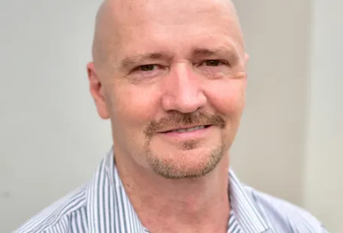

Uniting for a Cause: Join Us in Expanding The Mighty Warriors Ministry

We warmly invite organizations and individuals who feel called to support spiritual and humanitarian initiatives to join us as partners in faith. We seek benefactors who share our passion for making a meaningful impact through devotion and service.

The Mighty Warriors Ministry was born from a divine calling to reach over six million people worldwide. Our mission is to spread the Gospel and bring transformative change to communities in need through a holistic approach that encompasses spiritual growth, community service, and personal development.

At The Mighty Warriors Ministry, we believe that God has a unique purpose for each of us. My journey, though filled with challenges, has been a testament to God's unwavering presence and guidance. I am humbled by the call to establish an online ministry to reach six million people for Christ, fulfilling His mission and vision for His glory.

Our mission is to glorify Him, to help others recognize God's presence in their daily lives, and to share the hope that can only be found in Him. Let The Mighty Warriors Ministry be your guide, inspiring others on their spiritual journey with Christ.

Together, for God's glory, let's make a difference.
Allen Gibson
Website: www.themightywarriorsministry.com
Email: themightywarriorsministry54@gmail.com
Address: 2222 Aloha Drive 403
Honolulu Hawaii 96815

Vision Statement
To become a beacon of hope and spiritual renewal, reaching millions globally through the power of the Gospel, transforming lives, and fostering an international community of discipleship, support, and growth.
With God's support, our vision is not just a dream; it is a divine mission empowered by His strength and guidance. Embrace the vision, walk in faith, and trust that God, who began the good work, will bring it to completion. (Philippians 1:6, NIV).

Mission Statement
We are dedicated to fulfilling the great commission bestowed upon us by our Lord and Savior, Jesus Christ. We aim to reach as many people as possible by sharing the word of God through various mediums and have an international impact for God.
We appreciate the value of Christian fellowship, prayer, and worship. Our ministry is committed to helping people discover their gifts and passions and molding them into spiritual warriors for Christ. Join us as we spread the love of Jesus Christ throughout the world.
At Mighty Warriors Ministry, we are a vibrant community of believers united by an enthusiastic commitment to empowering and transforming lives through the unyielding love and power of Jesus Christ.
Our mission is to forge mighty warriors for God who, equipped with spiritual armor, courageously impact the world around them.

Our Core Values:
- Faith-Fueled Transformation: We believe in the transformative power of faith in Jesus Christ. Through dynamic worship, intentional discipleship, and unwavering prayer, we cultivate an environment where lives are continually being shaped into the image of our Mighty Savior.
- Radical Love in Action: Our ministry is fueled by a radical love that extends beyond the confines of our community. We are committed to actively demonstrating Christ's love through compassionate outreach, benevolence, and service to the world, making a tangible impact on lives in need.
- Empowering Leadership: At Mighty Warriors, we are committed to nurturing bold, visionary, and servant-hearted leaders. We provide a platform for individuals to discover, develop, and deploy their God-given gifts, fostering an atmosphere of empowerment and collaboration.
- Unwavering Spiritual Warfare: Recognizing the spiritual battles faced by individuals and communities, we equip our members with the whole armor of God.
- Through fervent prayer, steadfast faith, and strategic spiritual warfare, we stand firm against the forces of darkness, impacting lives and reclaiming territories for the Kingdom.

Beliefs
- Salvation through Jesus Christ is at the heart of what we believe at Mighty Warriors Ministry.
- We believe that Jesus died on the cross for our sins and was raised from the dead three days later.
- By accepting Jesus as our Lord and Savior, we open the door to eternal life in heaven.

The Mighty Warriors Ministry Foundation
- Scriptural Foundation: Firm belief in the teachings of the Bible as the infallible word of God.
- Discipleship: Commitment to nurturing believers to mature in their faith and witness to others.
- Community Impact: Dedication to making a positive impact on local and global communities through service and outreach.
- Inclusivity: Welcoming people from all walks of life and ages to find refuge, support, and growth in faith.

The Mighty Warriors Ministry Objectives
- Global Outreach: To reach six million + people worldwide with the message of the Gospel.
- Discipleship Training and Development: To provide rigorous training programs to develop spiritually mature Christians.
- Sub-Ministries Development: Including specialized ministries for teens, men, and women to address unique needs and challenges.
- International Impact: Establish international branches and support networks to aid in global mission efforts.
- Support Programs: Develop initiatives focused on mental health, homelessness, human trafficking victims, and veterans.

Projects and Ministries
- Mighty Teens Ministry: Programs tailored for teenagers' spiritual growth and challenges around the world.

- Mighty Men's Ministry: Focus on men's spiritual leadership and community and international involvement.

- Mighty Women Ministry: Empowering women through fellowship, study, and outreach international and in the community.

- Veterans' Home Initiative: Providing housing and spiritual support for our backyard and for those who have served around the world.

- Homeless Teens and Human Trafficking Outreach: Support services and rehabilitation programs.

- Mental Health Programs: Aligning with community and international partners spiritual support to those in need and to serve as a beacon of hope.

Role of The Mighty Warriors Ministry
International Christian Leadership Summits: Provide a platform for leaders from around the world to come together to discuss, strategize, and pray about the future of Christianity and its impact on global issues.
These summits focus on enhancing leadership skills, deepening theological understanding, and forging partnerships across continents to further the Gospel's reach.
The Mighty Warriors Ministry: Can significantly contribute to these summits by bringing fresh perspectives on outreach and discipleship.
With its focus on empowering individuals from diverse backgrounds, the ministry can share successful strategies on engaging underrepresented groups, fostering inclusive communities, and addressing contemporary social issues through a Biblical lens.
Workshops and Panels: Offering sessions led by experienced ministry leaders from The Mighty Warriors Ministry, focusing on innovative discipleship techniques, community impact strategies, and leadership development.
Resource Sharing: Providing comprehensive resources developed through the ministry’s various programs, including curriculum for youth and adults, guides for community service, and models for effective online ministry.
Networking: Utilizing the summit as a platform to form international partnerships, enhancing the ministry's global outreach and support network.
Women's Retreats
Positive Impact for women and the strength they bring to everyday life.
Women's retreats are vital for spiritual rejuvenation, personal growth, and community building. These retreats allow women to step away from the demands of daily life to connect deeply with God and one another in a supportive environment.
- Spiritual Growth: Focused Bible studies, worship sessions, and prayer groups help deepen faith and provide spiritual support.
- Empowerment: Workshops on leadership, personal development, and Biblical womanhood empower women to take active roles in their communities and churches.
- Mental and Emotional Health: Offering counseling sessions and seminars on dealing with stress, anxiety, and life transitions.
Men's Retreats
Men’s retreats focus on challenging and equipping men to be spiritual leaders in their families, workplaces, and communities. These events often combine teaching sessions with recreational activities, fostering camaraderie and accountability among participants.
- Leadership Training: Sessions on Biblical leadership, integrity, and influence to help men lead by example.
- Spiritual Workshops: In-depth Bible studies and prayer sessions aimed at spiritual strengthening and renewal.
- Community Building: Team-building activities designed to build trust and lifelong friendships among participants.
Teens Retreats
Teens retreats provide young people with a safe environment to explore their faith, question their beliefs without judgment, and learn how to apply Biblical principles to everyday life.
- Faith Formation: Engaging talks and interactive sessions that address real issues teens face, from peer pressure to faith in action.
- Leadership Development: Encouraging teens to take on leadership roles within the retreat and beyond, fostering a new generation of Christian leaders.
- Social Bonding: Activities that promote bonding, teamwork, and a sense of belonging among the youth.
In our world today, we need to ensure we have a clear vision for them, and that God is part of their everyday life.
Wisdom and Life Experiences: Senior Programs
Senior programs focusing on wisdom and life experiences are essential in preserving the heritage of faith while engaging the valuable insights and contributions of the older generation.
- Mentorship: Enabling seniors to mentor younger members of the community in faith, life skills, and leadership.
- Legacy Projects: Initiatives that allow seniors to contribute to lasting projects, such as community gardens, oral histories, or written works, ensuring their wisdom is passed on.
- International Dialogue: Seniors participate in forums or digital meetups with peers around the world, exchanging experiences and building international relationships.
The Mighty Warriors Ministry stands ready to make a profound impact both nationally and internationally through its diverse and inclusive programs. By leading in these areas, the ministry serves as a beacon of hope and transformation, acting as a voice for God and a powerful advocate for community change and spiritual renewal across generations.

As we embark on this mission, we are reminded of the words of Jesus in Matthew 5:14-16 (NIV): "You are the light of the world. A town built on a hill cannot be hidden. Neither do people light a lamp and put it under a bowl. Instead, they put it on its stand, and it gives light to everyone in the house. In the same way, let your light shine before others, that they may see your good deeds and glorify your Father in heaven."

Let us continue to shine brightly, illuminating the path for others and inspiring lasting change in the world. Together, we can make a difference that echoes through generations, all for the glory of God.

Strategic Programs
Youth Empowerment: Through mentorship and education, we aim to raise a generation of leaders who are both spiritually grounded and socially responsible.
Women’s Empowerment: We focus on equipping women with the skills and confidence to make significant contributions to their families and communities.
Health and Wellness: This initiative aims to provide essential health services, ensuring healthier communities with better life prospects.
Sustainable Community Development: From clean water projects to educational facilities, we are investing in infrastructure that sustains communities.
Global Outreach: Our international missions provide aid, spiritual support, and developmental assistance to some of the world’s most vulnerable regions.
Human Trafficking Program: Providing sanctuary and support to survivors, offering them a path to healing and empowerment through compassionate, Christ-centered care

Our Ministries Programs objectives and impacts
1. Youth Empowerment and Homeless Outreach Program
- Objective: To engage young individuals in spiritual, educational, and leadership activities.
- Impact: Equips the youth with life skills, spiritual grounding, and leadership qualities, fostering a new generation of community leaders.
2. Women’s and Men’s Outreach Initiative
- Objective: To support women and men through workshops, mentorship programs, and spiritual counseling.
- Impact: Empowers women to take active roles in their communities, enhancing family stability and economic independence.
3. Health and Wellness Services
- Objective: To provide basic healthcare, mental health services, and wellness education.
- Impact: Improves overall community health standards, reduces healthcare disparity, and promotes long-term well-being.
4. Community Development Projects
- Objective: To initiate sustainable development projects such as clean water facilities and educational centers.
- Impact: Builds infrastructure that supports self-sufficiency and boosts local economies.
5. International Missions
- Objective: To expand our outreach globally through partnerships, local missions, and support for international crisis areas.
- Impact: Provides global humanitarian aid, spreads the Gospel internationally, and fosters cross-cultural exchanges.

Highlights of our initiatives include:
- Christian Leadership International Development: This project aims to nurture and develop leaders who embody Christian values on an international scale, fostering a network of guidance and integrity.
- International Veterans Project: Here, we focus on giving back to those who have served, providing them with the support and resources needed to integrate spiritual and socially post-service.
- Homeless Teens and Victims of Human Trafficking: Through targeted support and rehabilitation, we aim to restore hope and provide new beginnings to some of the most vulnerable groups in society.
- Christian International Leadership Summit: An annual gathering designed to unite Christian leaders from around the world, promoting dialogue, shared learning, and collective action towards global challenges.
- Support for Mental Health: Recognizing the escalating mental health crisis, particularly among men under the age of forty-five, our ministry is committed to addressing and supporting mental health issues with compassion and effectiveness.
The Mighty Warriors Ministry also encompasses The Mighty Men Ministry, The Mighty Women Ministry, and special initiatives for young adults and seniors, ensuring that our reach and support extend to all demographics.

The Ministry Impact
The Mighty Warriors Ministry is not just an organization; it is a movement. With every program launched and every ministry established:
- We build stronger families and healthier communities.
- We empower the underprivileged and marginalized, giving them the tools to transform their own lives.
- We foster global understanding and peace through our international missions.
Why Invest in Us?
Investing in The Mighty Warriors Ministry means investing in the future of countless individuals worldwide. Your support helps us:
- Expand our reach to more communities and countries.
- Enhance the quality of our programs to deliver superior spiritual, educational, and humanitarian aid.
- Sustain long-term projects that pave the way for continuous improvement and growth.

Why Partner or become a benefactor with Us?
- The Mighty Warriors Ministry, born from a divine vision, has embarked on a mission to reach over six million people worldwide, spreading the Gospel and manifesting God’s glory across nations.
- As we lay the foundations of our ministry, we extend an invitation to you to join this holy endeavor as a benefactor. Your support will catalyze key projects that are crucial not only to our growth but also to the flourishing of countless lives touched by our work.
- As a potential benefactor, your support will not only help expand these vital programs but also ensure that we can reach our goal of changing six million lives.

Looking Forward
We are currently an LLC, transitioning to a nonprofit status, fully compliant with legal standards and dedicated to transparency and effectiveness.
Your partnership as a benefactor is not just a donation—it is a bridge to salvation and healing for many. As a token of our gratitude, benefactors will receive regular updates, have opportunities to visit project sites, and be acknowledged at our annual summits.
Rest assured, we are fully compliant with all necessary legalities, as outlined on our website, www.themightywarriorsministry.com.
Join us in this heavenly calling to change lives and spread hope. Every contribution, big or small, long-term, or one-time, makes a significant difference.
We need your support to fulfill this sacred mission. Together, let us build a legacy of faith, hope, and love.
Our Operating cost is included on the next page, we are not asking for someone to pay all the cost, just where God, Jesus and the Holy Spirit leads you to give to help us start on the right foot and make a bold impact for God international.
The Mighty Warriors Ministry seeks to make a profound impact both locally and internationally through its comprehensive ministry activities.
With a robust budget that reflects the ambitious goals of the ministry, we aim to reach, serve, and transform millions of lives around the globe.
We are committed to stewarding the resources entrusted to us with utmost integrity and effectiveness to fulfill God's vision.
Let us be reminded of the impactful words of Jesus in Luke 6:38 (NIV): “Give, and it will be given to you. A good measure, pressed down, shaken together and running over, will be poured into your lap. For with the measure you use, it will be measured to you.”
We believe this scripture to be true as it concerns the abundance that comes with giving and the rich return that your contributions will receive in the advancement of the kingdom of God. Your giving is not a mere donation but an investment toward salvation and healing that gives us the ability to reach and change lives all over the world. Partner with us in this great ministry and be blessed abundantly. Thank you for considering this opportunity!

Operational Cost Breakdown for The Mighty Warriors Ministry
This document provides a detailed breakdown of the operational costs for The Mighty Warriors Ministry. This is designed to ensure transparency and accountability as we seek the necessary funding to launch and sustain these vital ministry efforts.

Annual Operating Costs
- Staff Salaries: $300,000
Includes full-time focus for Allen Gibson.
- Utilities and Maintenance: $40,000
- Program Materials: $30,000
- Technology and Communication:
  - Website Development and Online Platforms: $15,000 initial + $5,000 annual maintenance
- Social Media Management and Digital Marketing: $10,000 annually

Specialized Programs and Support Services
- Veterans' Outreach and Homeless:
  - Setup: $100,000
  - Annual: $30,000
- Programs for Homeless Teens and Human Trafficking Victims: $175,000 annually
- Mental Health Outreach: $150,000 annually

Operation Setup
- Initial Program Startup: $100,000
- International Outreach Setup: $150,000

Global and Community Outreach
- International Travel and Summits: $150,000
- Travel and Logistics for Missions: $120,000
- Community and International Service Projects: $240,000

Total Costs
- Initial Setup Costs: $650,000
- Total First Year Operational Costs: $1,615,000

Together, let us build a legacy of faith, hope, and transformation. God bless you for your generosity and vision.

